Application Form for Music Lessons

Please complete and return to the school office

|  |  |  |  |
| --- | --- | --- | --- |
| **Student name:** |  | | |
| **Class:** |  | | |
| **Please tick which instrument family the student is interested in:** | | | |
| **Brass** (cornet, trumpet, tenor horn, French horn, baritone, euphonium, trombone, tuba) | | |  |
| **Guitar** (including ukulele) | | |  |
| **Keyboard** (including piano) | | |  |
| **Percussion** (including drum kit) | | |  |
| **Singing** | | |  |
| **Strings** (violin, viola, cello, double bass) | | |  |
| **Woodwind** (recorder, clarinet, flute, saxophone, oboe, bassoon) | | |  |
| By signing this form you confirm your understanding that lessons run for 11 weeks per term and payment must be made to the schools policies: | | | |
| Signed: |  |  | |
| Print name:  (parent / carer) |  |  | |
| Date: |  |  | |

*you could add more detail about the school policies here, or a link to where the information can be found*

Application for musical tuition at

________________________School

In Partnership with

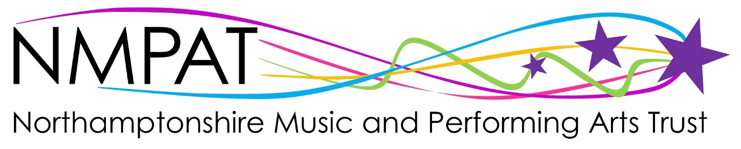

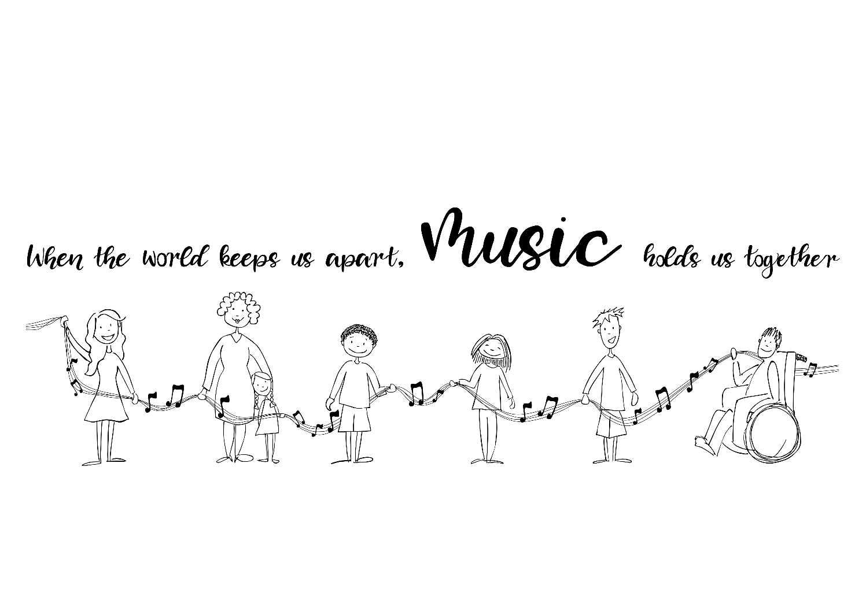

“Music makes an important contribution to the life of every school and it should be celebrated, promoted and encouraged. It helps build pupils’ self-esteem and

Self-discipline and leads to higher standards across the curriculum.”

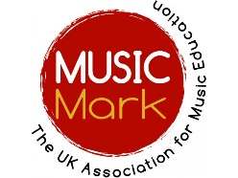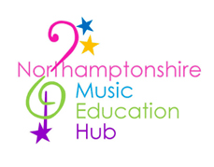

Dear parent / carer

Our school is happy to be able to offer your child the opportunity to take part in the following music lessons:

* Brass (cornet, trumpet, tenor horn, baritone, euphonium, trombone, tuba)
* Woodwind (recorder, clarinet, flute, saxophone, oboe, bassoon)
* Strings (violin, viola, cello, double bass)
* Guitar
* Keyboard
* Percussion / drum kit
* Vocal

Lessons are taught by the Northamptonshire Music and Performing Arts Trust (NMPAT) teachers, who will come into school throughout the year and deliver a total of 33 lessons.

Research has found that playing a musical instrument or singing is the equivalent of a full body **workout for the brain**.

Parents have found that learning to play an instrument or sing can help **grow confidence**.

Students have found it is **fun!**

Learning an instrument can support the development of literacy, numeracy and listening skills, as well as the skill of teamwork. Children learn mutual support and build a sense of co-operation within their learning groups.

Instruments for the lessons can usually be provided to beginners free of charge, with the exception of guitar, drums and keyboard. Advice on purchasing the correct instrument is available on request.

The charge for tuition is £_____________ per 11 week term.

If you need financial support, please contact the school office and enquire about any available schemes. There are also some assistance available through NMPAT: [www.nmpat.co.uk/support](http://www.nmpat.co.uk/support)

To register your child’s interest in music lessons please complete the attached form and return to the school office. Please note, in some cases of high demand, we may need to create a waiting list.

For more information about NMPAT and variety of the opportunities on offer, please go to [**www.NMPAT.co.uk**](http://www.NMPAT.co.uk)

**NMPAT commit to provide:**

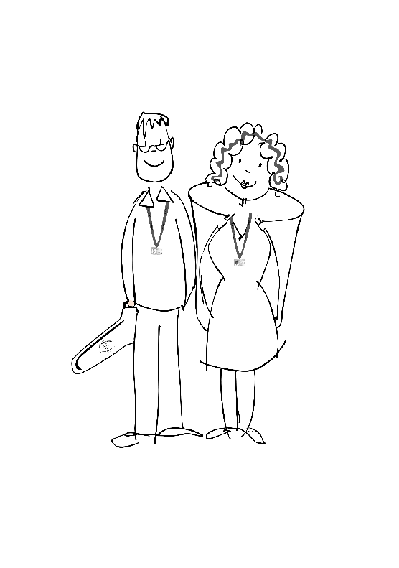

* Regular lessons by a qualified teacher with up to date information on the ways of playing an instrument and how to get the most out of your music lesson
* The loan of a string, woodwind or brass instrument for your first year of learning
* An opportunity to join your local Saturday Centre, full of music and performing arts opportunities for children and young people of all ages and abilities

More information on NMPAT commitments can be found at [www.nmpat.co.uk/policies](http://www.nmpat.co.uk/policies)

**Students are required to commit to:**

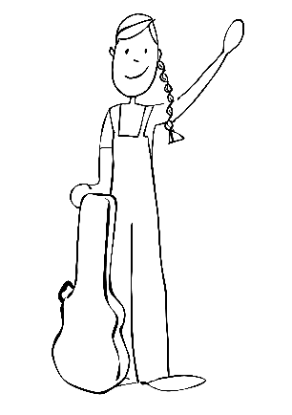

* Attend lessons regularly
* Look after any instrument provided as recommended by your teacher
* Regular practice and attendance at ensembles recommended by your teacher
* Enjoy making music!

More information on commitments from NMPAT, your school and yourself, as a learner, can be found at [www.nmpat.co.uk/policies](http://www.nmpat.co.uk/policies)

Please also refer to your schools own policies for terms and conditions on music lessons. *you could link the policies from here, or include any necessary detail*